1. Run sbt with options from terminal

SBT_OPTS="-agentlib:jdwp=transport=dt_socket,server=y,suspend=y,address=5004" sbt

2) Create new remote configuration in IntelliJ

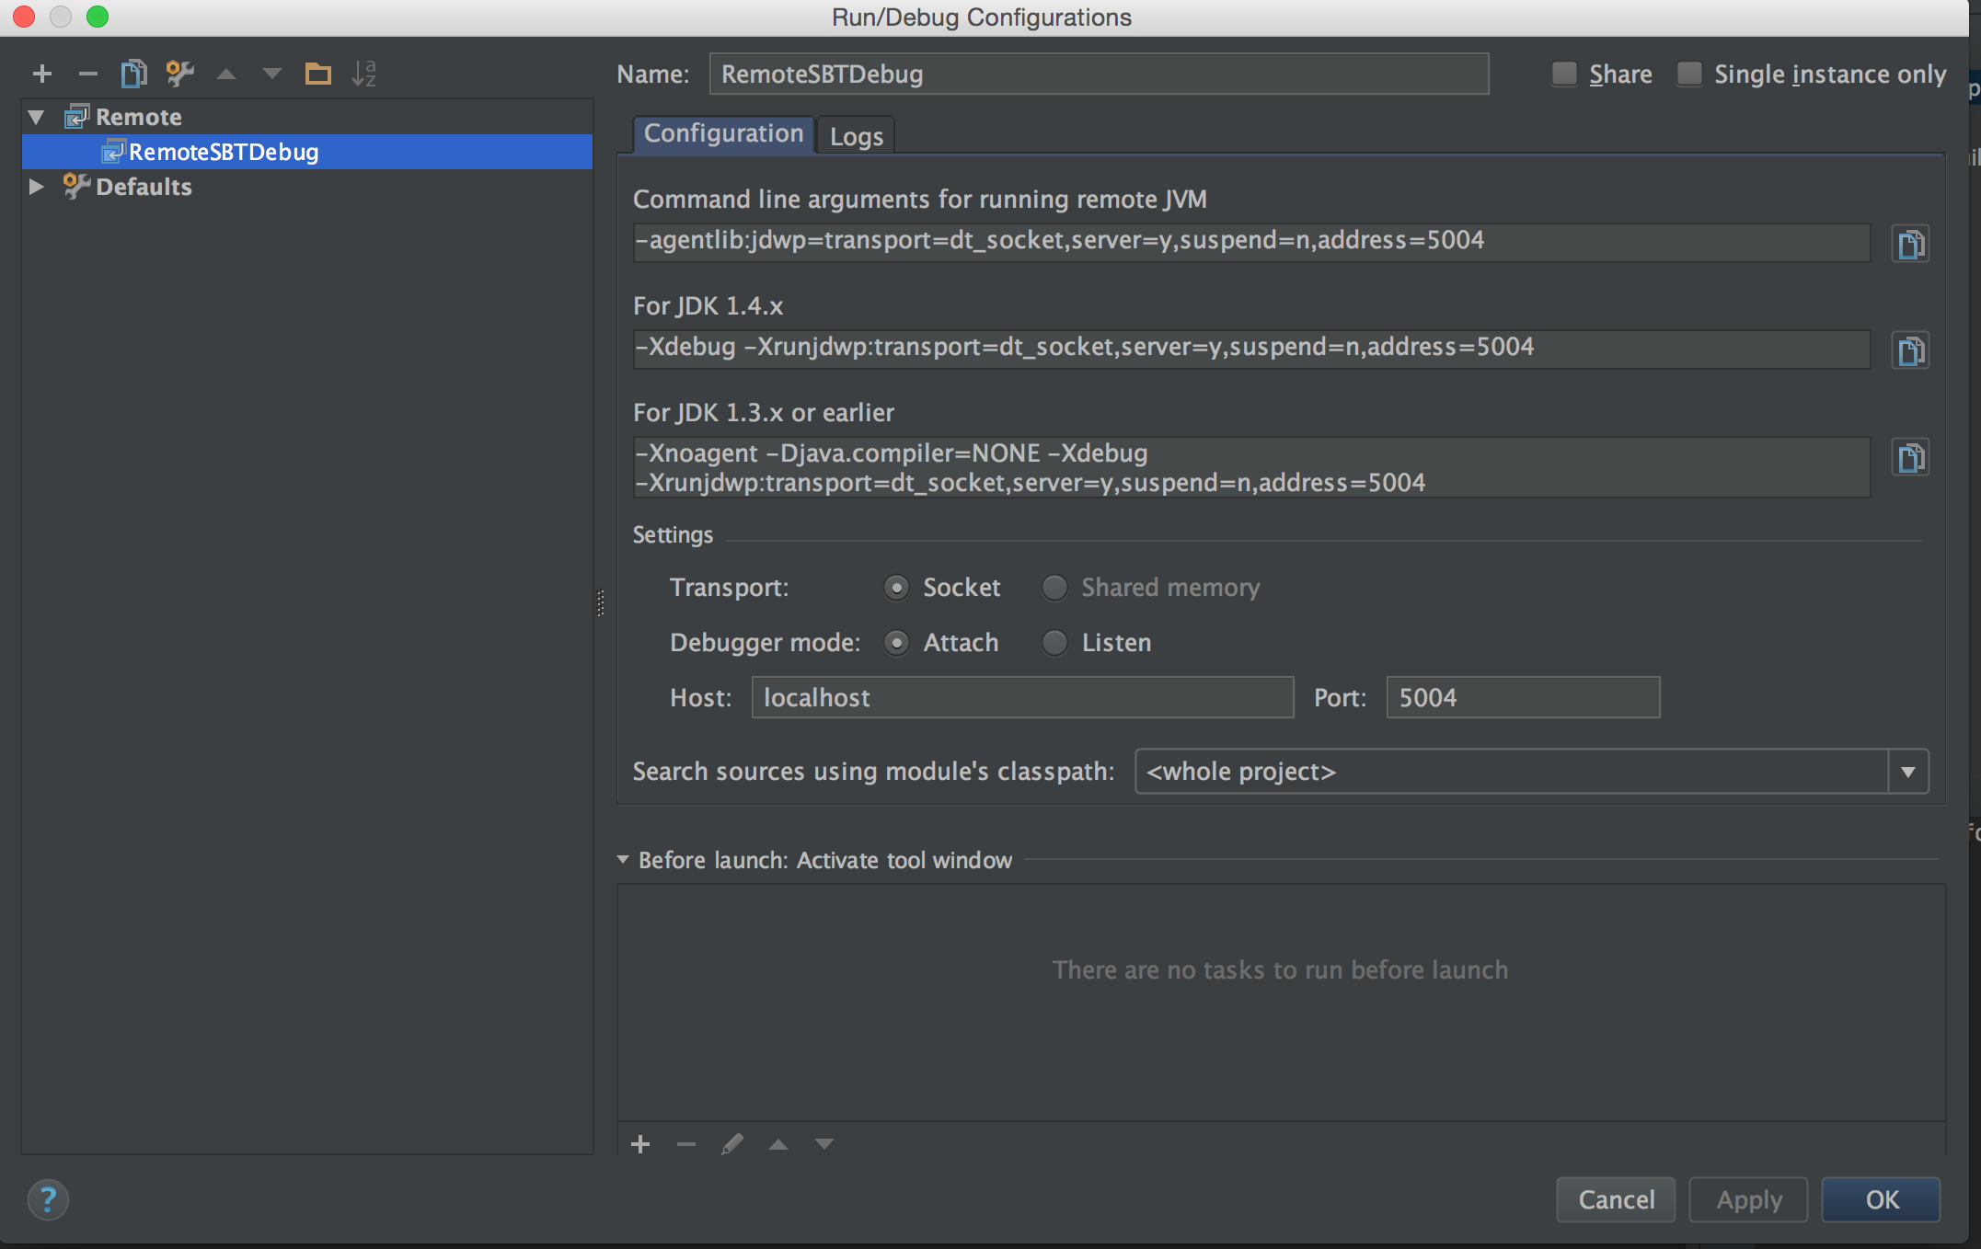

3) Set debug points in code

4) Run newly created configuration, it will attach IntelliJ to the sbt process

Connected to the target VM, address: 'localhost:5004', transport: 'socket'

5) Run tests from terminal sbt